EENG 385 - Electronic Devices and Circuits

BJT Curve Tracer: Pseudo Ramp Generator

Assembly Guide

# Assemble Pseudo Ramp Generator

This week, you will be soldering in the components in the Pseudo Ramp Generator area of the PCB shown in Figure 7.

I would suggest testing the values your capacitors using the component tester. Also be mindful that the transistor Q3 is a polarized part, so make sure the flat side of the BJT aligns with the flat side of the silk screen outline.

After you solder in all the components, test and correct any problems.

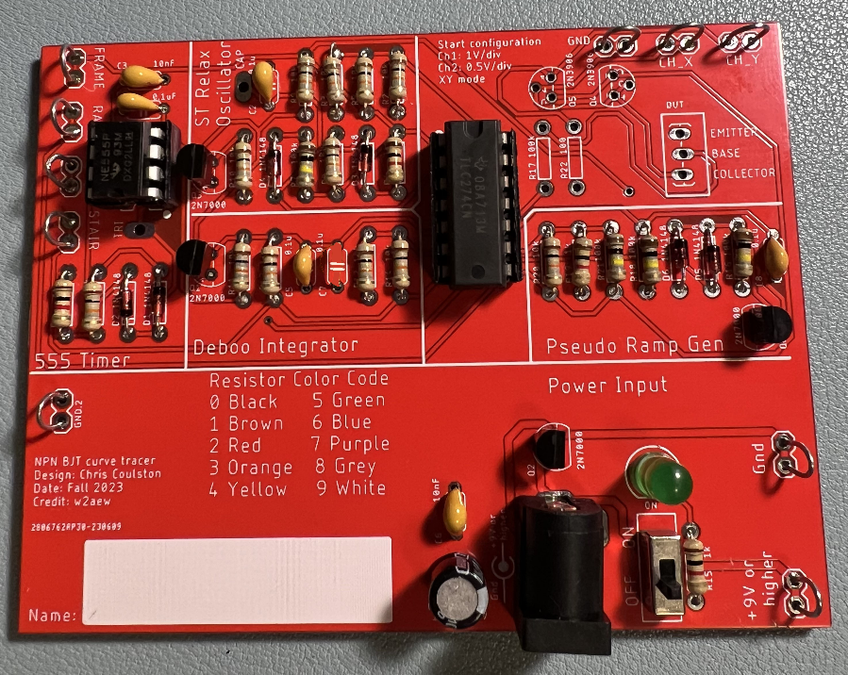

Figure : The completed Pseudo Ramp Generator.

# Debugging Pseudo Ramp Generator

I would expect most problems with this subsystem to be the result of:

* Bad solder connection
* Wrong component (resistor or capacitor)

If your BJT curve tracer board fails one of the test steps here is some guidance on what may have happened and how you can correct it.

1. If you are getting low resistance with the ON/OFF switch in the OFF position:
   * Make sure the ON/OFF switch is in the OFF position.
   * Make sure you are reading the DMM correctly.
2. If you are getting a different resistance with the ON/OFF switch in the ON position:
   * Make sure the ON/OFF switch is in the ON position.
   * Make sure you are reading the DMM correctly. The reading when the ON/OFF switch in the ON position will jump around a lot and probably be negative.
3. If the green LED does not illuminate when power is applied and the ON/OFF switch is in the ON position:
   * Test you are applying power. Put a DMM in voltage mode and check the +9V and Gnd test points.
   * Check for solder bridges on the rear of the PCB.
4. If you are not getting waveforms like the MultiSim Live simulation:
   * Check the board is powered up.
   * Check the oscilloscope leads are fully inserted.
   * Press the “Default Setup’” button to undo any weird configuration the last user may have left the oscilloscope in.
   * Check that solder connections by trying to wiggle each component. No visible movement should be possible.